1. All the previous lecture not required for overview.

# 39. Kafka Producer Configuration Properties

1. 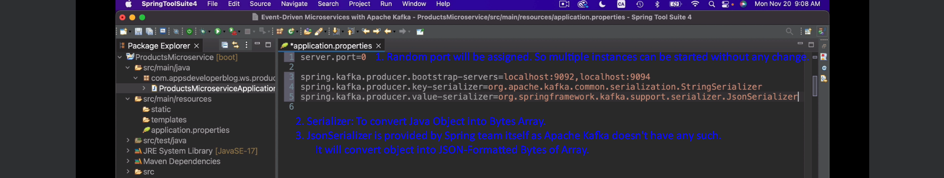

# 40. Creating Kafka Topic